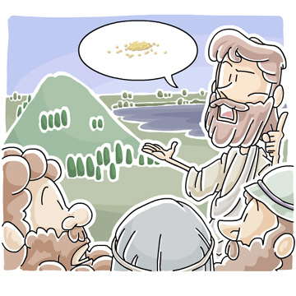
“What is Faith? Object Lesson”
Children’s Sermon on Luke 17:1-5 and 2 Timothy 1:1-14
Children’s Message: What is Faith?
Passing Faith Along to spread God’s Word
Main Objective: Faith can be a somewhat difficult topic to discuss with younger children, as it is one of those intangible elements that we sometimes struggle to describe. This message aims to emphasize for students that faith is not about us, but is about hope in what GOD does. As we trust in Him, we also want to tell others about Him.
Law/Gospel Theme: Our faith does not need to be huge or super-spiritual, and is not about certain words or exercises. Faith is a strong assurance if it is founded in God, who is worthy of our trust and faith. Jesus is the “founder and perfecter of our faith” and makes it possible for us to know God.
Optional Materials: Two Clear pitchers or jars; water; baking soda; vinegar
Bible Passage: 2 Timothy 1:1-14; Luke 17:5-10
Bonus Ideas: More ideas and activities for teaching this children’s message
- Watch the video teaching example of this object lesson message
- See all our object lesson sermons for kids
- Download our F is for Faith Coloring Pages from the Bible Alphabet Coloring Book
- See our Bible craft ideas about Faith

Faith -- Children’s Sermon / Object Lesson
(Adjustable, depending on audience and equipment....)
Greet students and introduce the topic.
Hello, children of God!
How are you today? I have a question for you: what is faith? We talk about it a lot…but what do you think it is? (Pause for potential answers)
Do you think that faith is about who we are and how well we believe something? Or is it about the thing that we believe? (Again allow for answers…this question might be slightly tricky)
Well, the Bible tells us that faith is “the assurance of things hoped for”, meaning that it has to do with believing something you do not necessarily see and touch. In our Bible lessons today, there was talk about faith, and how that hope can dwell in us. People were asking Jesus to help them grow their faith. But you know, faith is not just like a muscle that we can somehow do special things to improve and grow. Faith is not all about us, but about what we are putting our faith in. I want to show you something… (Take out the jars/pitchers, along with a bag or cup of baking soda).
So let’s say that this is faith (hold up baking soda)…and let’s say I have faith in something like, I’ll turn into a pumpkin if I swallow a pumpkin seed, or that purple unicorns are going to come stampeding the town. If I think I believe that, I might put “faith” in it, and I might even tell other people about it, but if my faith is founded in purple unicorns (pour some baking soda into water and watch not much happen), well, it doesn’t do much, does it? Sort of just falls flat.
Hmm… But on the other hand, let’s say that I place my faith in something that is worthwhile, and actually has power. Let’s say that this (hold up vinegar. Tip: Know which jar has water and which contains vinegar!) is God. Now, if I have faith in God’s words, it does not take much on my part (put a little bit of baking soda into the vinegar, and watch it fizz up) for amazing things to happen! The faith itself was not as important as what we put it in. This is what Jesus was talking about when He said that faith could be as small as a tiny seed.
We don’t have to do special things to grow our faith. We just have to know and accept what God has already done for us. He sent Jesus to cover our sins and allow us to have closer connection with Him. We might not see God with our eyes, but we know what He has done and continues to do. We trust that the Bible is true and comes from God. And we hope in the knowledge of His incredible gifts.
You know what else? We don’t have to keep that understanding to ourselves. We hear the Word of God from parents, teachers, pastors, or others in our lives. And we can pass it on. It’s important to tell people about what we believe, so they can know more about Jesus and want to follow Him, too! Then it will create some great reactions, just like the fizzing we saw when this “faith powder” entered the special liquid. What a great privilege and opportunity! Why don’t we say a prayer and thank God for that?

Children’s Prayer Moment
(Have kids repeat each line)
Dear God,
Thank you for all of your blessings
Thank you for the words of the Bible
Thank you for being worthy of our trust
And help us as we put our faith in you
Help us to tell others about you, too!
We love you, God!
Thank you for Jesus
In His name, Amen!

Scriptures about Faith
The apostles said to the Lord, “Increase our faith!”⁶ He replied, “If you have faith as small as a mustard seed, you can say to this mulberry tree, ‘Be uprooted and planted in the sea,’ and it will obey you. ⁷ “Suppose one of you has a servant plowing or looking after the sheep. Will he say to the servant when he comes in from the field, ‘Come along now and sit down to eat’? ⁸ Won’t he rather say, ‘Prepare my supper, get yourself ready and wait on me while I eat and drink; after that you may eat and drink’? ⁹ Will he thank the servant because he did what he was told to do? ¹⁰ So you also, when you have done everything you were told to do, should say, ‘We are unworthy servants; we have only done our duty.’” Luke 17:5-10 NIV
Now faith is the assurance of things hoped for, the conviction of things not seen. ² For by it the people of old received their commendation. ³ By faith we understand that the universe was created by the word of God, so that what is seen was not made out of things that are visible. –Hebrews 11:1-3
I am reminded of your sincere faith, a faith that dwelt first in your grandmother Lois and your mother Eunice and now, I am sure, dwells in you as well. 6 For this reason I remind you to fan into flame the gift of God, which is in you through the laying on of my hands, 7 for God gave us a spirit not of fear but of power and love and self-control.
8 Therefore do not be ashamed of the testimony about our Lord, nor of me his prisoner, but share in suffering for the gospel by the power of God, 9 who saved us and called us to a holy calling, not because of our works but because of his own purpose and grace, which he gave us in Christ Jesus before the ages began, 10 and which now has been manifested through the appearing of our Savior Christ Jesus, who abolished death and brought life and immortality to light through the gospel, 11 for which I was appointed a preacher and apostle and teacher, 12 which is why I suffer as I do. But I am not ashamed, for I know whom I have believed, and I am convinced that he is able to guard until that day what has been entrusted to me. 13 Follow the pattern of the sound words that you have heard from me, in the faith and love that are in Christ Jesus. 14 By the Holy Spirit who dwells within us, guard the good deposit entrusted to you. -2 Timothy 1:5-14

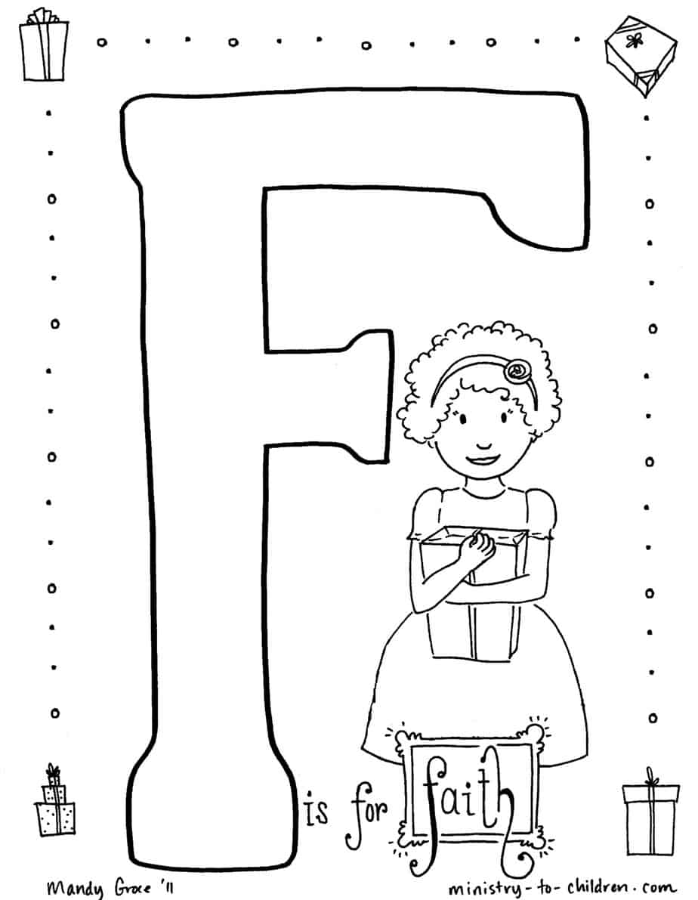
We hope you enjoy this free resource.
Everything from Ministry-To-Chidren.com is 100% free to copy & use in ministry.

I’m Tony Kummer - I started this website in 2007, but God is using it beyond my imagination. The mission is simple.
Help you tell kids about Jesus!
Our team is honored that you choose our material. Thank you for …
- serving where God has placed you.
- telling children about Jesus.
- allowing us to be a part of your mission.

We don’t ask for money, but we do need your help.
Please consider the following:
- Comment on the website to encourage our authors.
- Link to us from your blog or church website.
- Share our posts on Pinterest or Facebook.
- Tell a friend to google “Ministry to Children.”
- Add me (and our team) to your personal prayer list.

I’d love to hear your feedback on this download. Tony@ministry-to-children.com
May God bless you and continue to bless your ministry!

